Ex: No: RAILWAY RESERVATION SYSTEM
Date:

AIM:
To Design ,Implement and Test the E-ticketing system described in the given problem statement .
PROBLEM STATEMENT
E-ticketing system gives an idea about how tickets are maintained in the particular websites. The tickets that are to be booked, the tickets that are to be sold are maintained here. Further some additional details of the current journey details that is available in the website are also given. E-ticketing system in this project is done in an authorized way. The website has to be maintained properly since the whole e-ticketing process can be improved. E-ticketing system in this project gives the idea about how tickets are maintained in a particular concern. The ticket details which includes the number of seats available and price.E-ticketing system in this project is understood by going through the modules that is being involved
The main objective of this project is to overcome the work load and time consumption which makes the maintenance of the tickets in an organization as a tedious process. This project provides complete information about the details of the tickets to the customers. This project identifies the amount of tickets available. Separate modules have been created for purchasing, viewing ticket details, and payment details.

USECASE DIAGRAM:

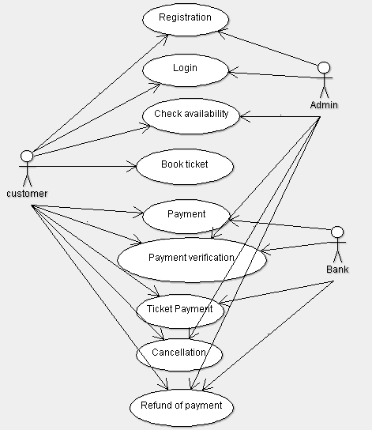

CLASS DIAGRAM:

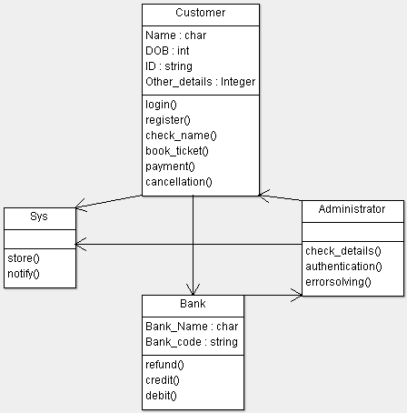

SEQUENCE DIAGRAM:

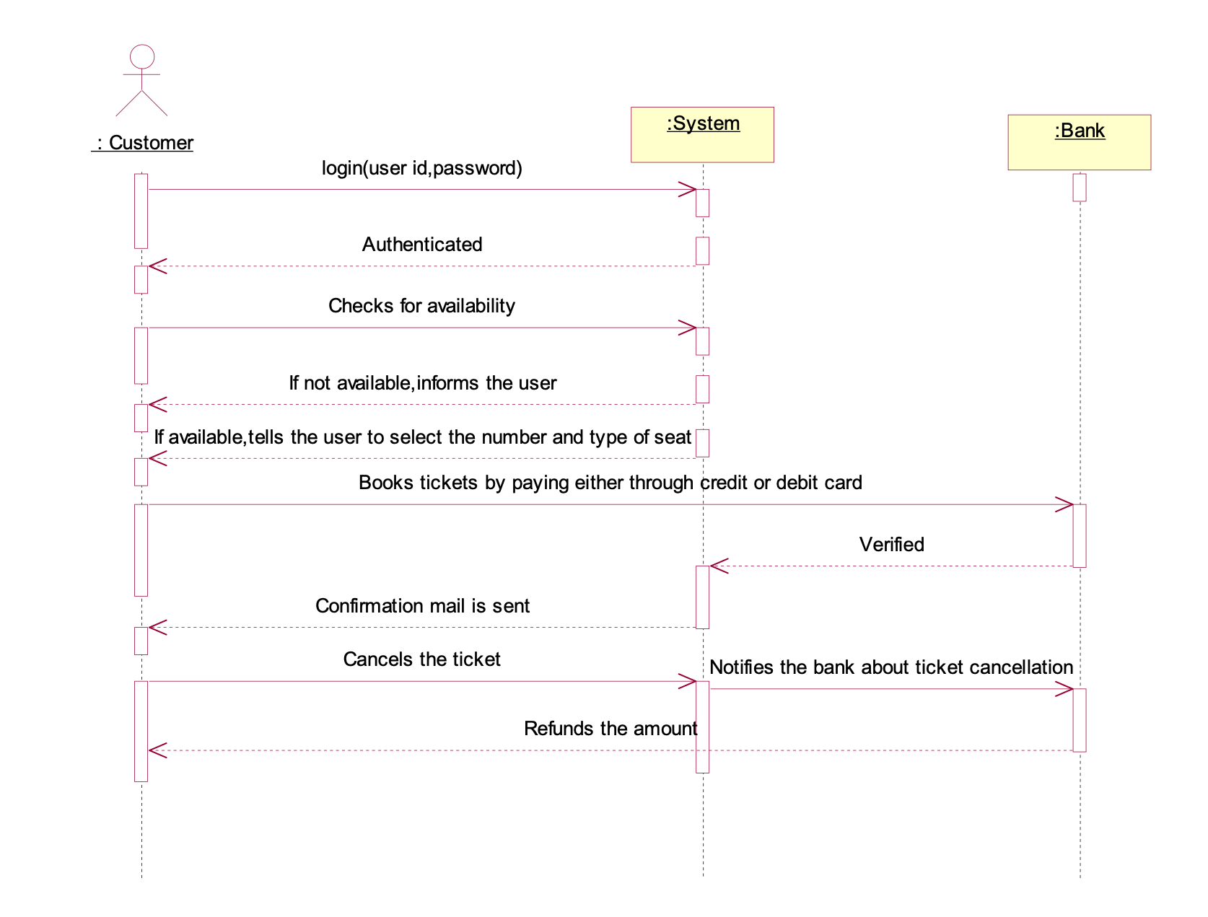

ACTIVITY DIAGRAM:

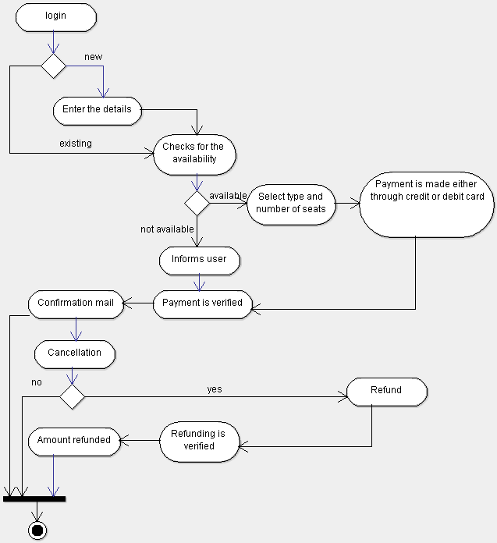

STATE CHART DIAGRAM:

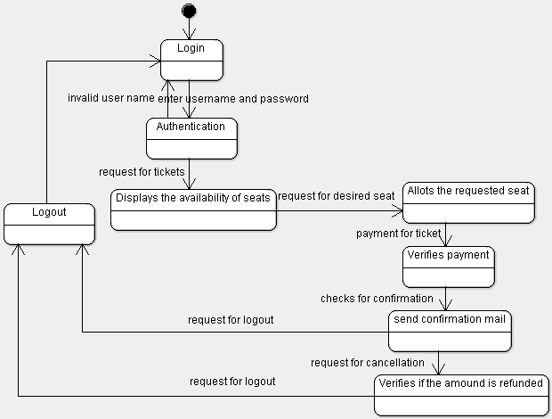

COMPONENT DIAGRAM:

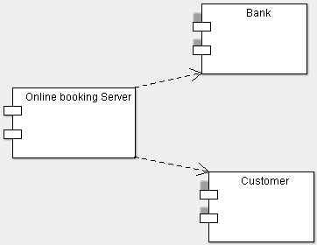

DEPLOYMENT DIAGRAM:

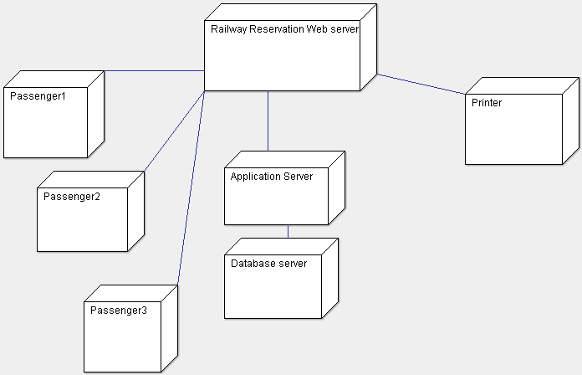

IMPLEMENTATION & TESTING
Flight.java
import java.util.*;
public class Flight {
static Scanner s=new Scanner(System.in);
public static Availability a=new Availability();
public static int choice;
public static Booking b=new Booking();
public static Cancellation c=new Cancellation();
public static void main(String[] args)
{
while(choice!=4)
{
System.out.println("****************Welcome to Airline E-Ticket Booking System*************");
System.out.println("Select your service");
System.out.println("1.Check Availability");
System.out.println("2.Book Ticket");
System.out.println("3.Cancel Ticket");
System.out.println("4.Exit");
choice=s.nextInt();
if(choice==1)
{
a.check_availability();
}
else if(choice==2)
{
b.start_booking(a);
}
else if(choice==3)
{
c.cancel(a,b);
}

}

}

}

Availability.java
import java.util.*;
public class Availability {
public int flight_no[]={2102,1521,4531,4654,8465};
public String flight_name[]={"SpiceJet","IndiGo ","KingFisher","Air Asia","Jet Airways"};
public int avail[]={50,100,45,88,55};

public void check_availability()
{
System.out.println("The list of available Flights");
System.out.println("Flight No\tFlight Name\tAvailable");
for(int i=0;i<5;i++)
{
System.out.println(flight_no[i]+"\t\t"+flight_name[i]+"\t"+avail[i]);
}
}
}
Booking.java
import java.util.*;
public class Booking {
public static Scanner s=new Scanner(System.in);
public int f_no;
public String f_name;
public String p_name;
public String destination;
public int seats;
public Random r=new Random();
public int ticket_no;
public boolean found;
public int flight_index;
public void start_booking(Availability a)
{
int i;
found=false;
System.out.println("*************Welcome To Booking Wizard*************");
System.out.println("Enter the Flight No");
f_no=s.nextInt();
System.out.println("Enter the passenger name");
p_name=s.next();
System.out.println("Enter the Destination");
destination=s.next();
System.out.println("Enter the No.of seats required");
seats=s.nextInt();
System.out.println("We are processing your request....");
System.out.println("Please wait a while....");
for(i=0;i<5;i++)
{
if(a.flight_no[i]==f_no)
{
a.avail[i]=a.avail[i]-seats;
flight_index=i;
f_name=a.flight_name[i];
found=true;
}
}
if(found)
{
ticket_no=r.nextInt(5000)+1234;
System.out.println("***************DETAILS**************");
System.out.println("Passenger Name: "+p_name);
System.out.println("Flight Name: "+f_name);
System.out.println("Flight No: "+f_no);
System.out.println("Destination: "+destination);
System.out.println("No.of Seats booked: "+seats);
System.out.println("Your Ticket No:"+ticket_no);
}
else
System.out.println("You have entered WRONG Flight No.");

}
}

Cancellation.java
import java.util.*;
public class Cancellation{
public static Scanner s=new Scanner(System.in);
public int t_no;
public void cancel(Availability a,Booking b)
{
System.out.println("**********Welcome to Cancellation Wizard*************");
System.out.println("Please enter your ticket no");
t_no=s.nextInt();
if(t_no==b.ticket_no)
{
System.out.println("Processing Your request.....");
System.out.println("Initiating Cancellation.....");
a.avail[b.flight_index]+=b.seats;
b.ticket_no=0;
System.out.println("Successfully processed your request");
}
else
System.out.println("OOPS!!! Seems like you have entered wrong ticket number...");
}
}

OUTPUT:
****************Welcome to Airline E-Ticket Booking System*************
Select your service
1.Check Availability
2.Book Ticket
3.Cancel Ticket
4.Exit
1
The list of available Flights
Flight No Flight Name Available
2102 SpiceJet 50
1521 IndiGo 100
4531 KingFisher 45
4654 Air Asia 88
8465 Jet Airways 55
****************Welcome to Airline E-Ticket Booking System*************
Select your service
1.Check Availability
2.Book Ticket
3.Cancel Ticket
4.Exit
2
*************Welcome To Booking Wizard*************
Enter the Flight No
1521
Enter the passenger name
Rakesh
Enter the Destination
Chennai
Enter the No.of seats required
7
We are processing your request....
Please wait a while....
***************DETAILS**************
Passenger Name: Rakesh
Flight Name: IndiGo
Flight No: 1521
Destination: Chennai
No.of Seats booked: 7
Your Ticket No:1964
****************Welcome to Airline E-Ticket Booking System*************
Select your service
1.Check Availability
2.Book Ticket
3.Cancel Ticket
4.Exit
1
The list of available Flights
Flight No Flight Name Available
2102 SpiceJet 50
1521 IndiGo 93
4531 KingFisher 45
4654 Air Asia 88
8465 Jet Airways 55
****************Welcome to Airline E-Ticket Booking System*************
Select your service
1.Check Availability
2.Book Ticket
3.Cancel Ticket
4.Exit
3
**********Welcome to Cancellation Wizard*************
Please enter your ticket no
1964
Processing Your request.....
Initiating Cancellation.....
Successfully processed your request
****************Welcome to Airline E-Ticket Booking System*************
Select your service
1.Check Availability
2.Book Ticket
3.Cancel Ticket
4.Exit
1
The list of available Flights
Flight No Flight Name Available
2102 SpiceJet 50
1521 IndiGo 100
4531 KingFisher 45
4654 Air Asia 88
8465 Jet Airways 55
****************Welcome to Airline E-Ticket Booking System*************

Select your service
1.Check Availability
2.Book Ticket
3.Cancel Ticket
4.Exit
4
TEST REPORT 1
Product : E-TICKET BOOKING SYSTEM
Use Case : Check Availability

Test Case ID | Test Case / Action To Perform | Expected Result | Actual Result | Pass/Fail
- c | Enter into “check availability” | Display the list of flights with it’s availability | Displays  The list of available Flights  Flight No FlightName Available  2102 SpiceJet 50  1521 IndiGo 100  4531 KingFisher 45  4654 Air Asia 88  8465 Jet Airways 55 | Pass
2 | Pressed 4 | Exits from the system | Exit | Pass

TEST REPORT 2
Product : E-Ticket Booking System
Use Case : Book ticket
Test Case ID | Test Case / Action To Perform | Expected Result | Actual Result | Pass/Fail
1 | Enter into “Booking wizard” | Gets the details from the passenger | Enter the Flight No  1521  Enter the passenger name  Piyush  Enter the Destination  Chennai  Enter the No.of seats required  7 | Pass
 | Enters wrong flight number | Displays the error message | You have entered WRONG Flight No. | Pass
2 | Providing all the correct details | Displays the ticket for the journey | Passenger Name: Piyush  Flight Name: IndiGo  Flight No: 1521  Destination: Chennai  No.of Seats booked: 7  Your Ticket No:1964 | Pass

TEST REPORT 3
Product : E-Ticket Booking System
Use Case : Cancel Ticket
Test Case ID | Test Case / Action To Perform | Expected Result | Actual Result | Pass/Fail
1 | Enter into “Cancellation wizard” | Displays cancellation  Screen | Please enter your ticket no | Pass
2 | Enter the correct ticket no. | Displays the confirmation message | Processing Your request...  Initiating Cancellation.....  Successfully processed your request | Pass
3 | Enter the wrong ticket number | Displays the error message | OOPS!!! Seems like you have entered wrong ticket number... | Pass

